Let’s get the boring questions out of the way!
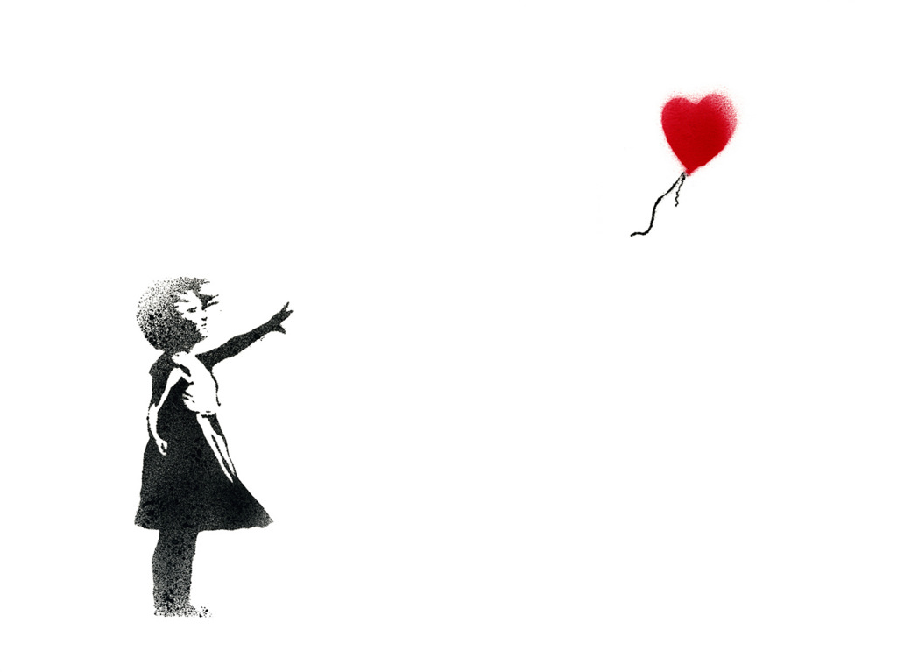

How long have you two been together?

How did you meet?

What was ‘that moment like’?

Was there a song playing/line used/a memorable venue that really sticks in your head?

Was there a moment when you said to yourself – I think that this is it?

Were there some rocky moments – moments where you could have cheerfully killed each other?

When thinking about other weddings that you have been to

What did you really like?

What did you think was outdated/boring/not you?

What is a message that you would like people at your wedding to know about the both of you?

Is there a moment when things have been tough and together as a team you have overcome it and it has made you stronger?

Is there something special/specific that you would like included in your ceremony?

Are there specific people/places that you would like to mention in your ceremony?

Is there something that you want to talk about but NOT MENTIONED IN THE CEREMONY (hahah)

